ASSIGNMENT 3.2
Name: pooja chittaluri
Roll Number: 2303A51186
Batch - 03
20-01-2026

Task Description-1
• Progressive Prompting for Calculator Design: Ask the AI to design a simple calculator
program by initially providing only the function name. Gradually enhance the prompt by
adding comments and usage examples.
Expected Output-1
• Comparison showing improvement in AI-generated calculator logic and structure.
Task Description-2
• Refining Prompts for Sorting Logic: Start with a vague prompt for sorting student marks,
then refine it to clearly specify sorting order and constraints.
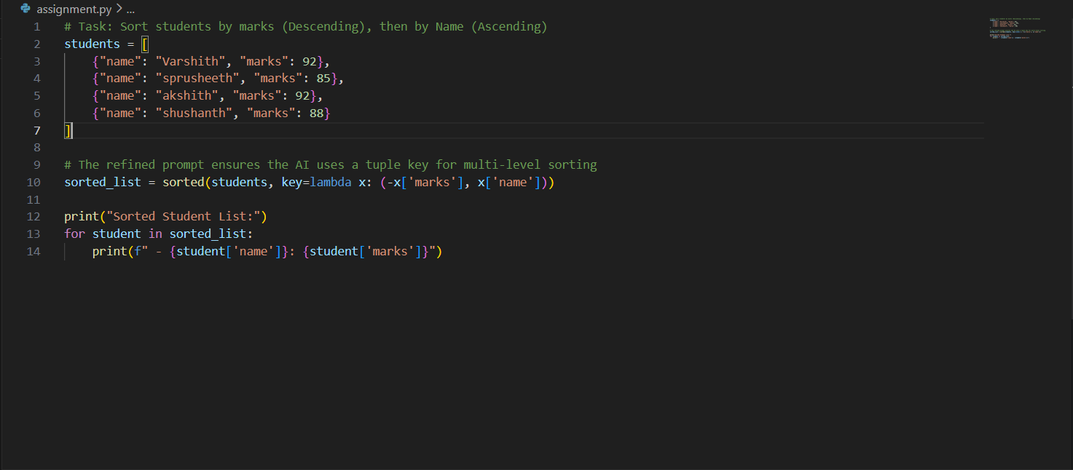
Expected Output-2
• AI-generated sorting function evolves from ambiguous logic to an accurate and efficient
implementation.
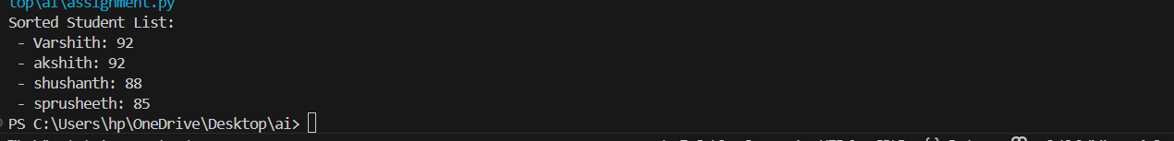
Task Description-3
• Few-Shot Prompting for Prime Number Validation: Provide multiple input-output
examples for a function that checks whether a number is prime. Observe how few-shot
prompting improves correctness.
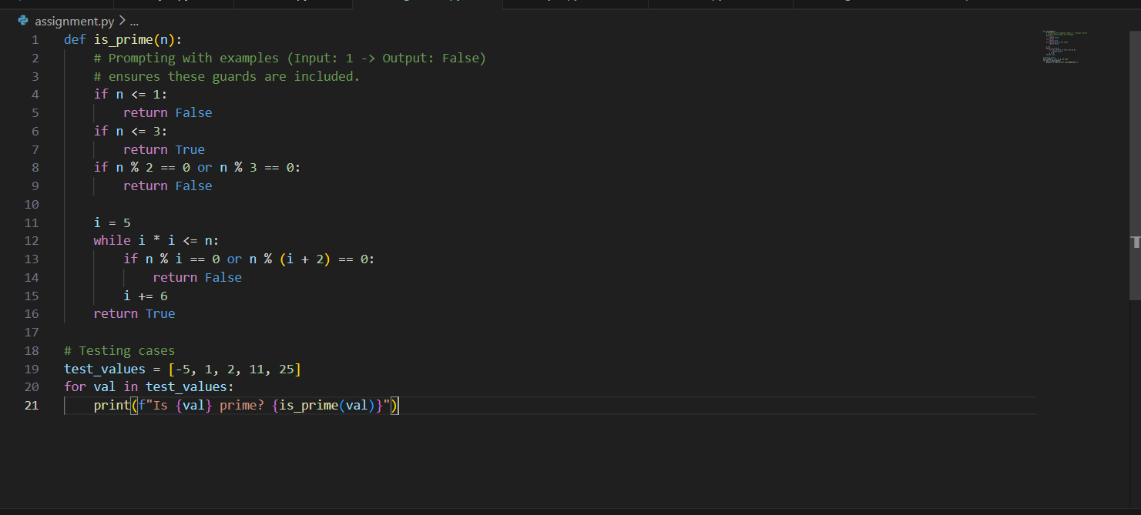
Expected Output-3
• Improved prime-checking function with better edge-case handling.
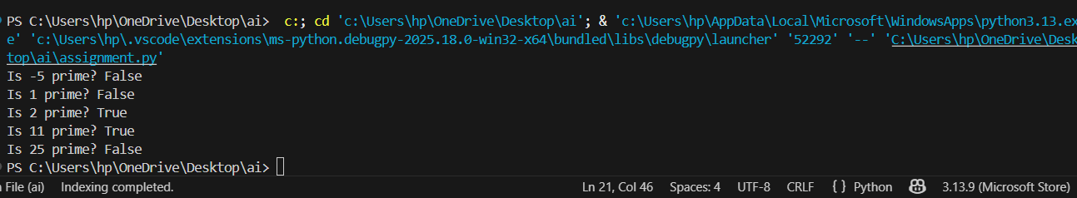
Task Description-4
• Prompt-Guided UI Design for Student Grading System: Create a user interface for a
student grading system that calculates total marks, percentage, and grade based on user
input.
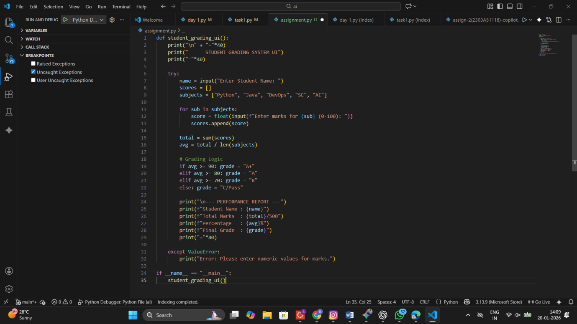

Expected Output-4
• Well-structured UI code with accurate calculations and clear output display.
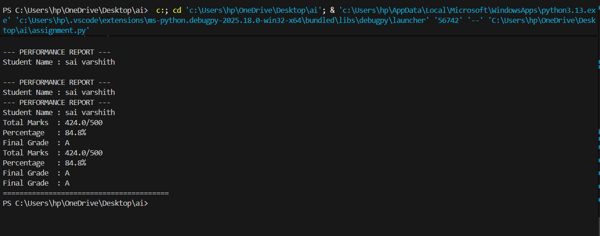
Task Description-5
• Analyzing Prompt Specificity in Unit Conversion Functions: Improving a Unit
Conversion Function (Kilometers to Miles and Miles to Kilometers) Using Clear
Instructions.
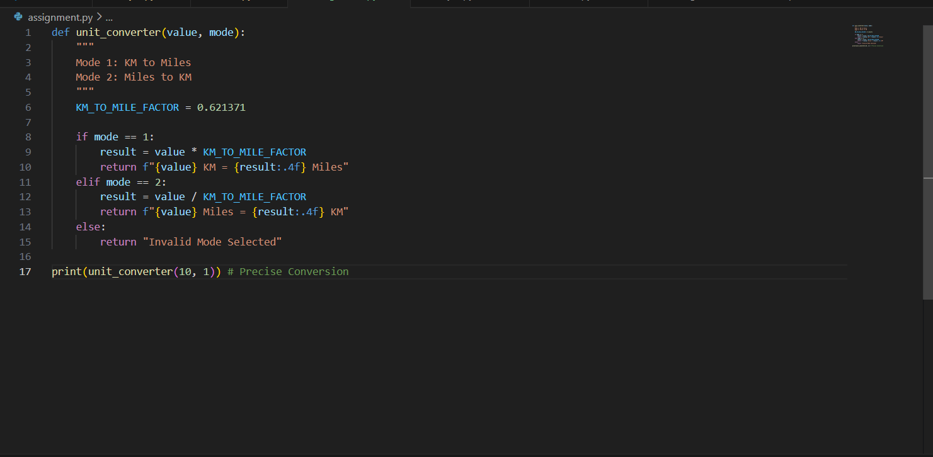
Expected Output-5
• Analysis of code quality and accuracy differences across multiple prompt variations.
